**Component Name**: Quick UI Routing

**Component Functionality**:

Quick UI Routing is kind of a website with menu’s and specific icons displays basic information on selection of the specific menu in the application. Also contains child component like Header, Footer, Contact etc.

**Usage Areas**:

This reusable component can be integrated with any page and use the features and make appropriate changes as per the requirement.

**Component Technical details**:

* React version: 16.13.1
* Bootstrap version: 3.3.7

We have a single component which renders rest of the components so as to perform all the operation related to the menu items along with the header and the footer

**How this component can be integrated with other Applications**:

As it is a reusable component we will have to integrate within our application and make use of all the menu item features.

**Screenshots**:

1. Initial Screen with Menu.

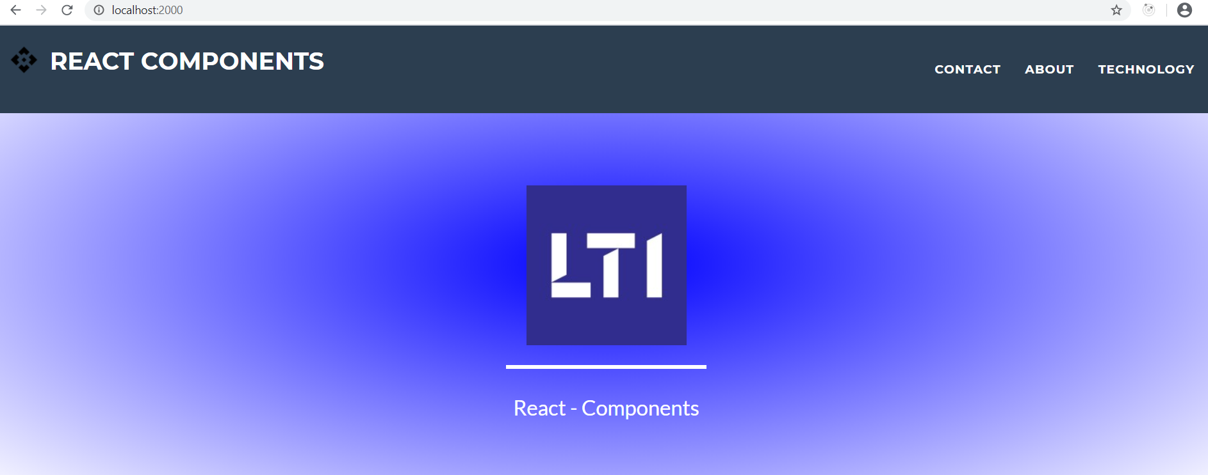

1. Contact Screen on selection of Contact from Menu.

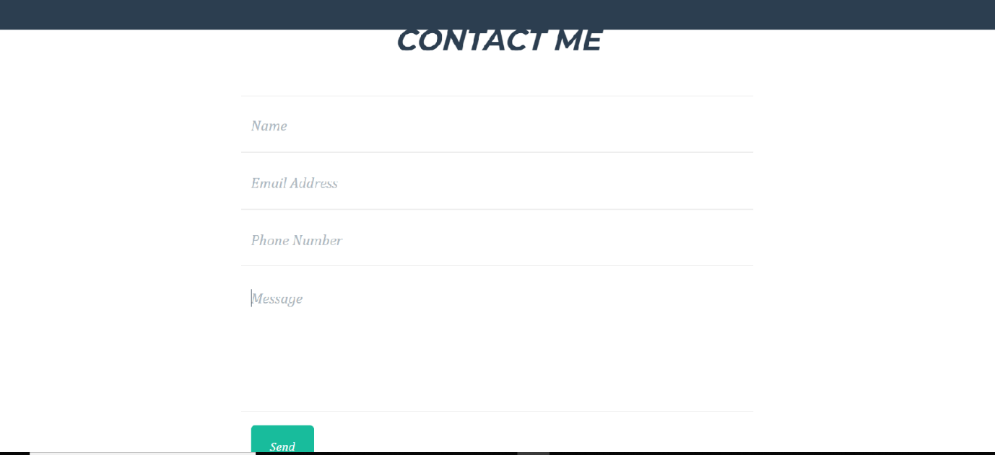

1. About Screen on selection of About from Menu.

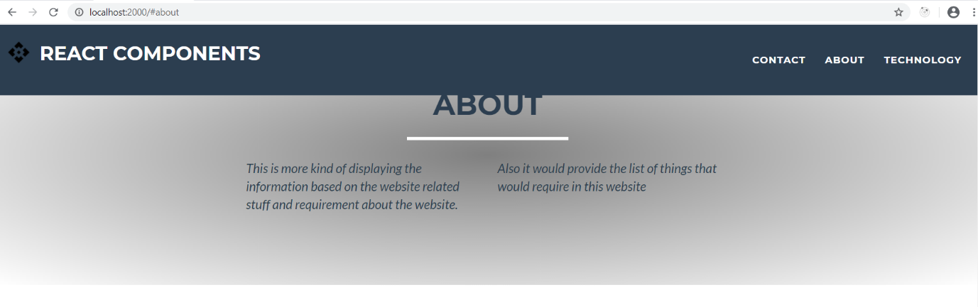

1. Technology Screen on selection of Technology from Menu.

